Name________________________________________________ Date______________

SKILLS EVALUATION
Math A. Solve each problem.

14.02
4.86
27 813 1326 551 431 213.01 97.32 5 1455
x9 +509 -851 x.03 x16 -17.85 +165.01

15% of 75=_______________

Math B. Solve the following problems.

- Add 4 feet 8 inches, + 5 feet 4 inches, + 7 inches, + 2 feet 8 inches._________
- Add 9 minutes 14 seconds, + 37 minutes 10 seconds, + 45 seconds._________
- If you had to load 490 boxes into crates, and each crate holds 7 boxes, how many crates would you need?_________________
- If you lived 1 mile from the grocery store and you decided to walk how long would it take you to get there if you walked 4 miles per hour?_____________
- At Albertson’s, chicken costs $1.15per pound. If you bought 2 pounds and paid for it with a $20 bill, how much change would you get?______________

Filing.
In the space provided, write the alphabetical section in which each company should be filed.

ALPHABETICAL SECTIONS
Aa-Bb Fa-Hz Na-Oz
Bc_Cf Ia-Kz Pa-Rz Example: Sa-Uz Smith & Baker
Cg-Dz La-Md Sa-Uz
Ea-Fz Me-Mz Va-Zz

______Personnel Plus ______Becon Bakery
______Holiday Paradise ______Landscape Pro’s
______Smith and Company ______Kaiser Medical Center
______Morris Fertilizer ______Nomads Truck Stop
______Eaton Testing Laboratory ______Valley Shopping Center

Ruler A. Find the following measurements of locations A, B, C, in inches.
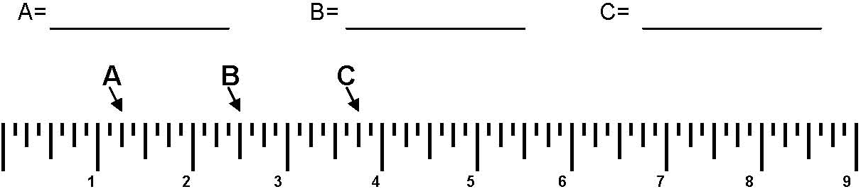
Ruler B. Draw arrows pointing to the following measurements on the ruler below.
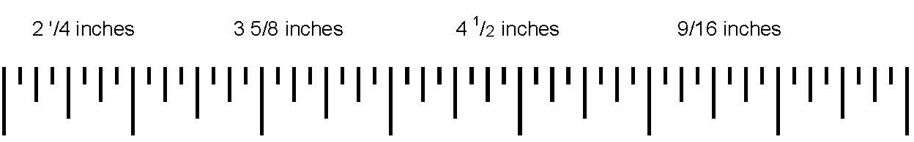

Comparison A. Put an X in the space if the two lists are NOT the same.

__________1.Ethan Jacobson Ethan Jacobsen
__________2. Larry Smith Larrie Smith
__________3. Troy Cooper Troy Cooper
__________4. Hank Williams Hank Wiliams
__________5. Pat Paterson Pat Peterson
__________6. Paul O’rion Paul O’Rion
__________7. Edward D. English Edward B. English
__________8. Angie Walker Angy Walker
__________9. Sean W. Baker Sean W. Baker
__________10. Mary Ann Gold Mary Ann Gold

Comparison B. Put and X in the Space if the sets are NOT the same.

______1. 2481 2481 ______11. 6966536 3996653
______2. 1096 1051 ______12. 84728476 84725476
______3. 1157 1175 ______13. 6524867 6524867
______4. 13569 13569 ______14. 142568 142568
______5. 19765 19765 ______15. 654987 654987
______6. G11560 G1560 ______16. J568894 J56894
______7. 365877 366587 ______17. X156T9 X156T9
______8. 79562K 79562K ______18. 56847 56847
______9. 17715563 17715563 ______19. 872315 8723315
______10. 5683 5683 ______20. 1568797 1568779

Spelling. Mark each Misspelled word.
______attentian ______argument ______cordially ______difinitely
______repition ______occurrence ______priviledge ______separate
______comparative ______beginning ______extraordianry ______favorite
______dispair ______alltogether ______hazardus ______representative
______availability ______conscience ______assistance ______miscelaneous
______absense ______similar ______occasion ______conferred
______desription ______suggestion ______numberical ______accommodate
______misspell ______maintenance ______responsible ______embarass
______ready ______garantee ______sincerely ______gracious
______suitable ______incidental ______analyze ______unneccesary

